Practical No 1

**Name:-Vishwajit kate**

**Reg. No:-2020BIT011**

* ***Write C/C++ code to implement concept of***

***1)Stack 2)Queue 3)Linked List 4)Trees 5)Graphs***

* Stack
* Code:

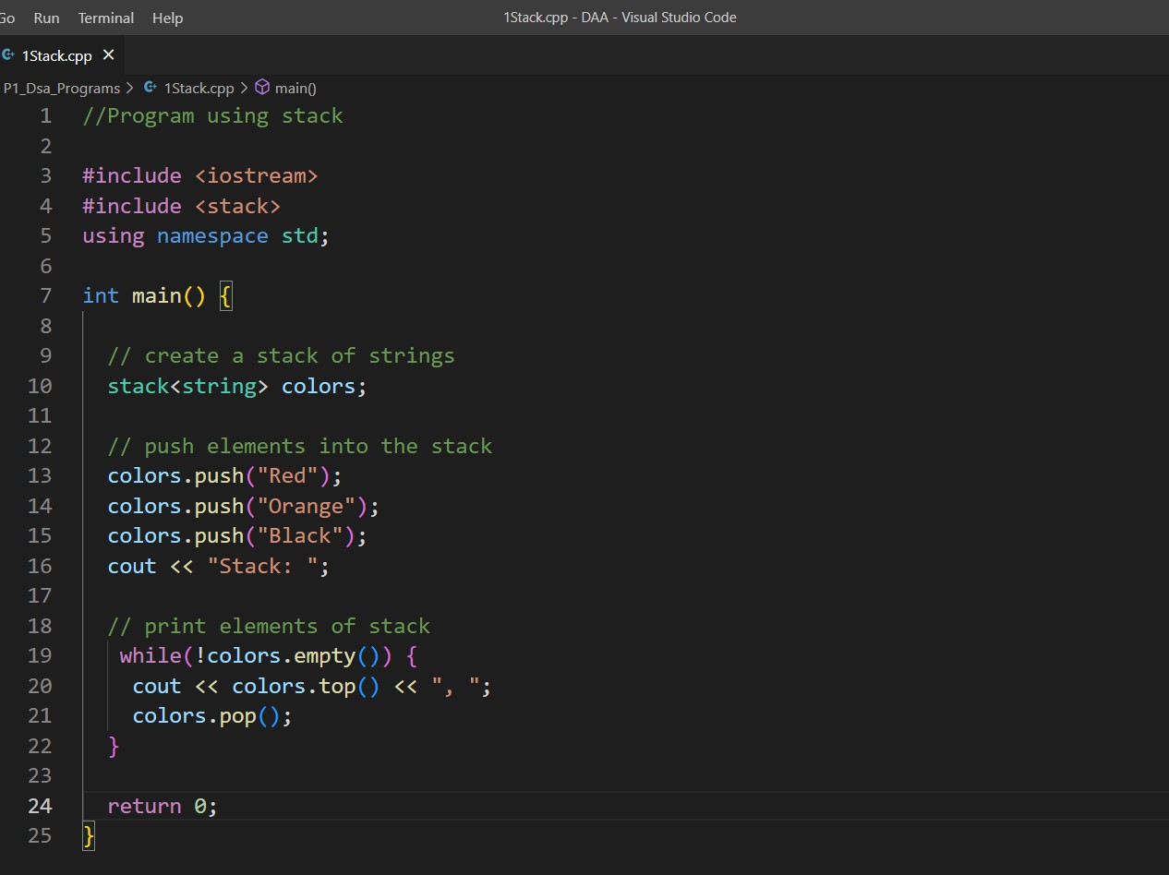

Output:

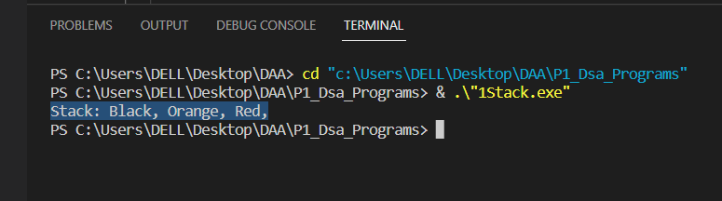

* Queue
* Code:

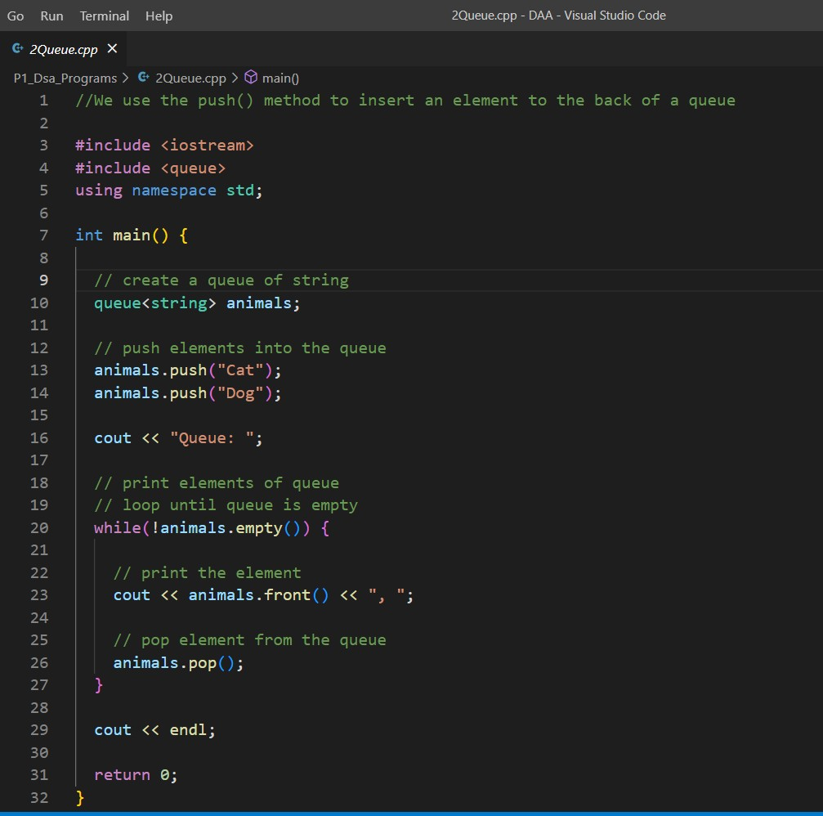

Output:

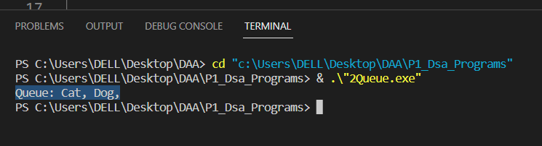

* Linked List
* Code:

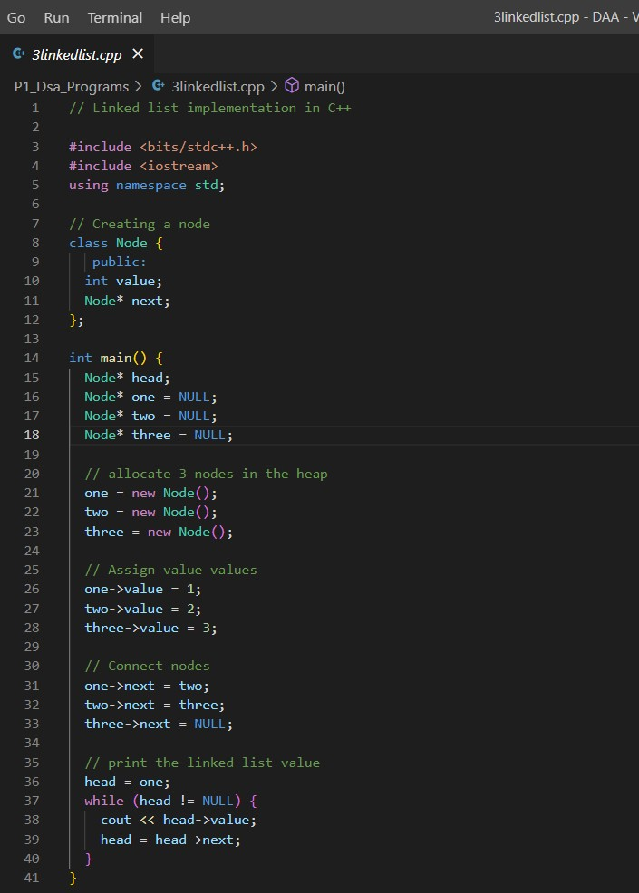

Output:

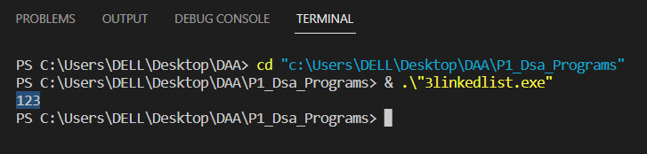

* Trees
* Code:

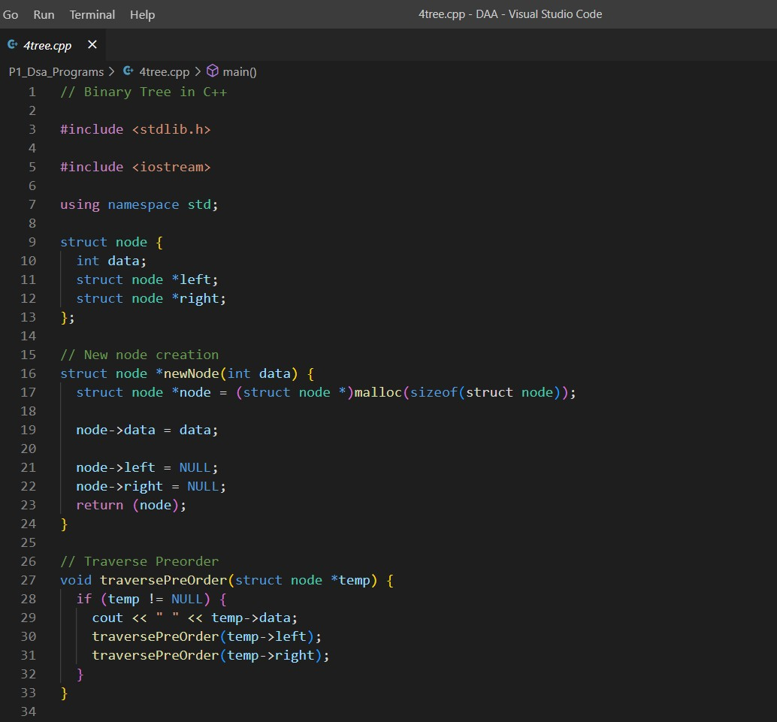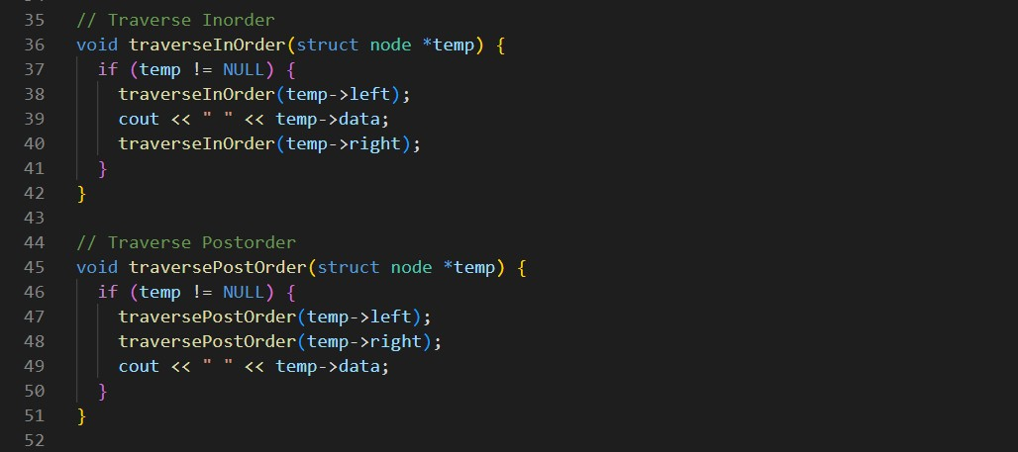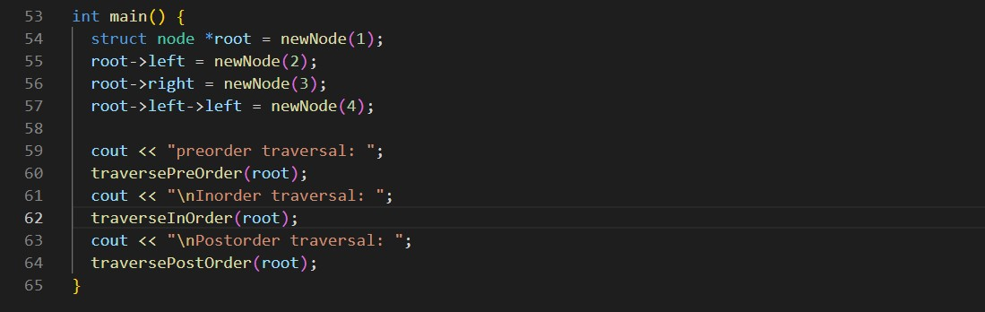

Output:

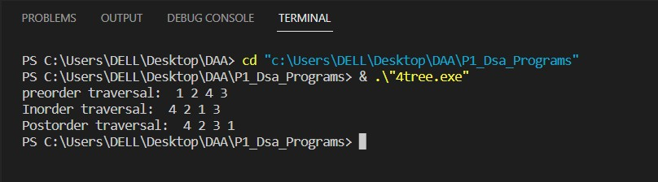

* Graphs

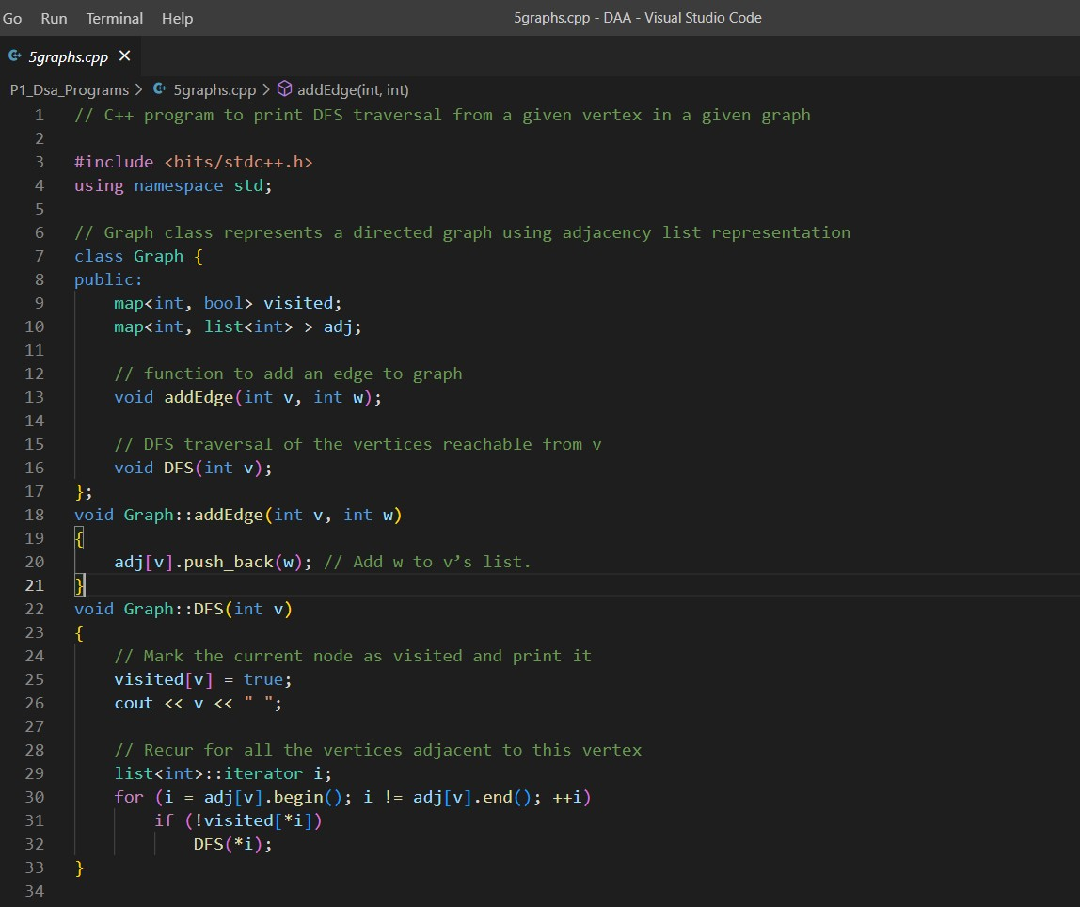

* Code:
* Code:

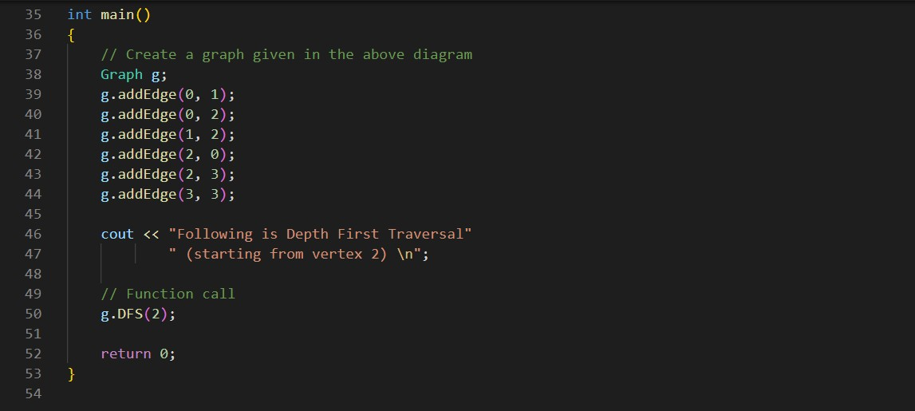

Output:

